THE UNIVERSITY OF AZAD 
JAMMU & KASHMIR

Department of Software Engineering

GRAPHIC DESIGNING
ASSIGNMENT
Instructor Name: MAM FATIMA
Semester: 4th
Session: 2024 – 28

Name: Raja Ali Shan
Roll No: 2024 – SET – 18

Women in Technology Poster Assignment

Part A: Poster
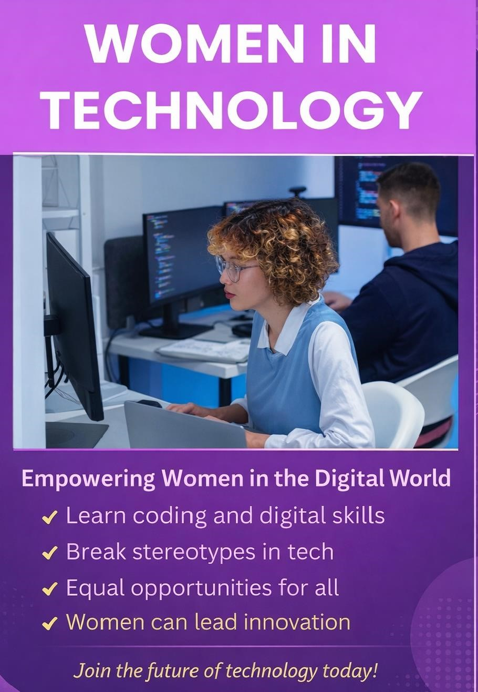

Part B: Explanation
I designed my poster on the topic “Women in Technology” to promote the role of women in the modern digital world. I used a purple gradient background because it represents creativity, innovation, and empowerment. The gradient effect adds depth and makes the design visually appealing. White color is used for the title to create strong contrast and make it bold and attention-grabbing. For the supporting text and bullet points, I used a combination of white and soft yellow tones to maintain readability while highlighting important information. I selected two fonts to keep the design clean and professional. A bold font is used for the title to emphasize importance, while a simple font is used for the body text to ensure clarity. I added a high-quality image of a woman working on a computer to visually represent the concept of women in technology. The layout is wellstructured with proper spacing and alignment, making it easy to read. Overall, the design is modern, balanced, and effectively communicates the message.

Part C: Class Explanation
Today I am presenting my poster on the topic “Women in Technology.” The main purpose of my poster is to highlight the importance of women in the field of technology and to encourage more women to participate in the digital world.
In my design, I used a purple color theme because it represents creativity, innovation, and empowerment. I also used a gradient background to make the poster more modern and visually attractive. The title is written in bold white color so that it grabs attention immediately.
I used simple and clean fonts to make the text easy to read. I added an image of a woman working on a computer to clearly show the idea of women being active in technology. In the lower part of the poster, I included important points such as learning coding skills, breaking stereotypes, and providing equal opportunities. These points help the audience quickly understand the message.
Overall, my poster is simple, balanced, and easy to understand. It delivers a strong message that women can play an important role in the future of technology.
Thank you.

